**AWS Billing Alarm**

**Inside the billing dash board Enter in to Top Free Tier services**

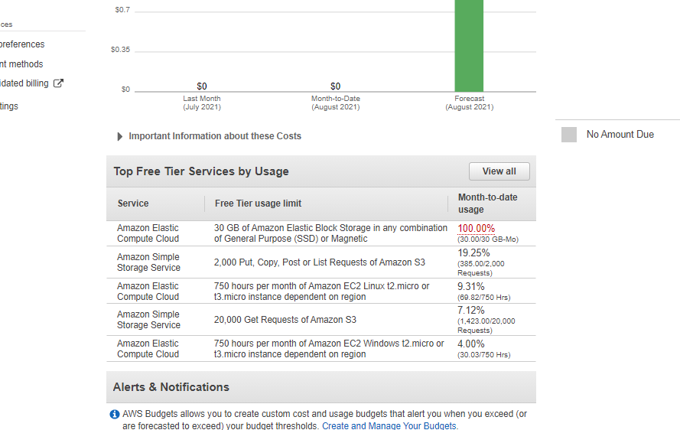

**Click View all:**

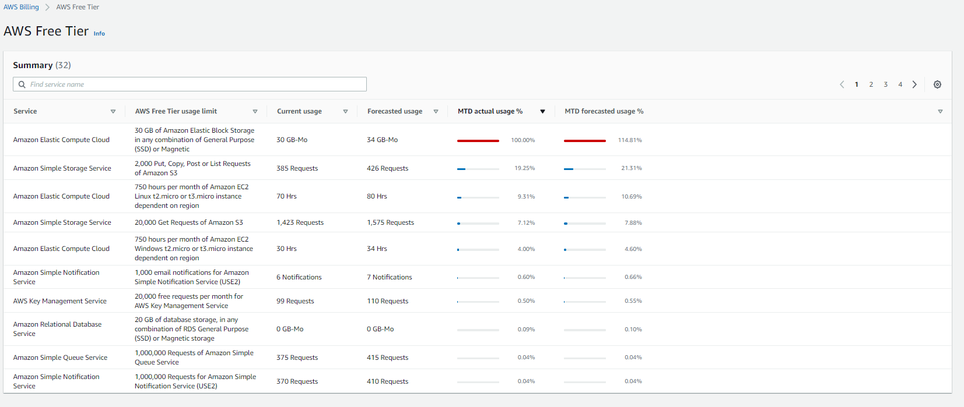

**Using this you can check you free tier limit usage.**

**Apart from this if you didn’t monitor this status manually, you may forget to release the elastic IP and you may forget to stop the instances in this case there is chance for billing.**

**In this situation billing alarm can help you.**

**The companies which are using AWS service will have their limit to use the services within the fixed amount like 500$ or 1000$, when it is yet to exceed the range the billing alarm will help them to control the usage.**

**Demo:**

**Steps:**

1. **Enter into billing preferences.**

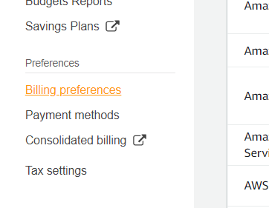

1. **Check-in into “receive billing” alerts and if you want you can check-in into “receive pdf invoice By Email”.**

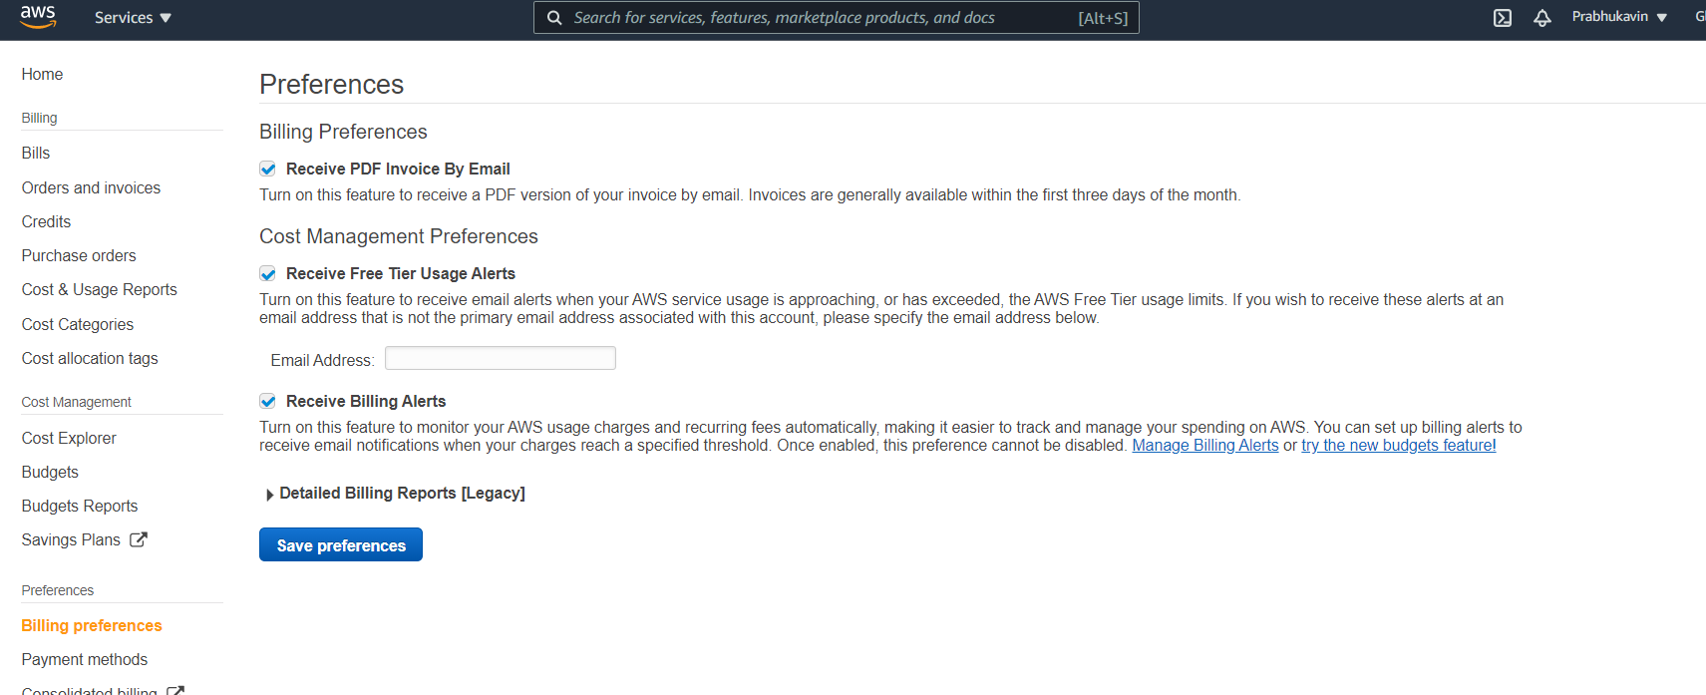

**Click save preferences.**

1. **Next, we are going to monitor this Billing using the “Cloud watch alarm”.**

**Enter into CloudWatch.**

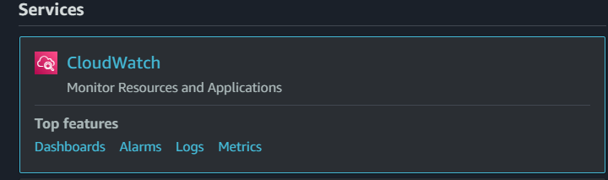

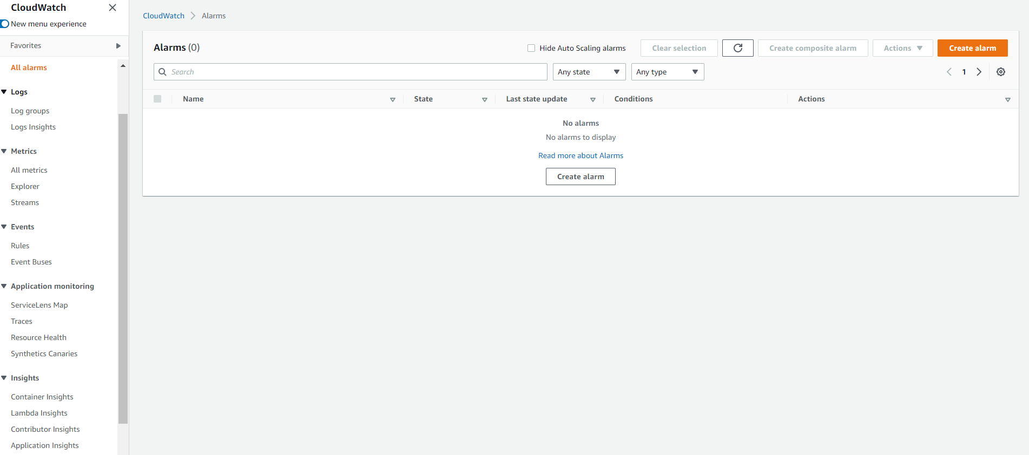

**Note : We may avail the service from any region in AWS but the billing alarm can only be created from the region “N.Virginia”.**

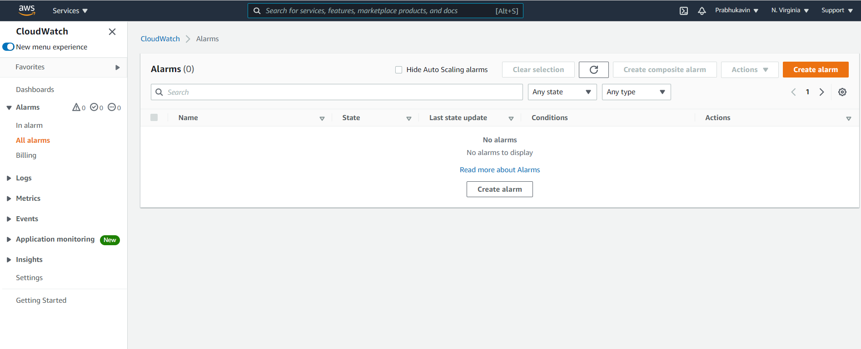

1. **Click on Billing:**

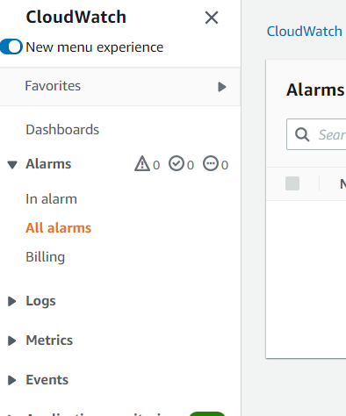

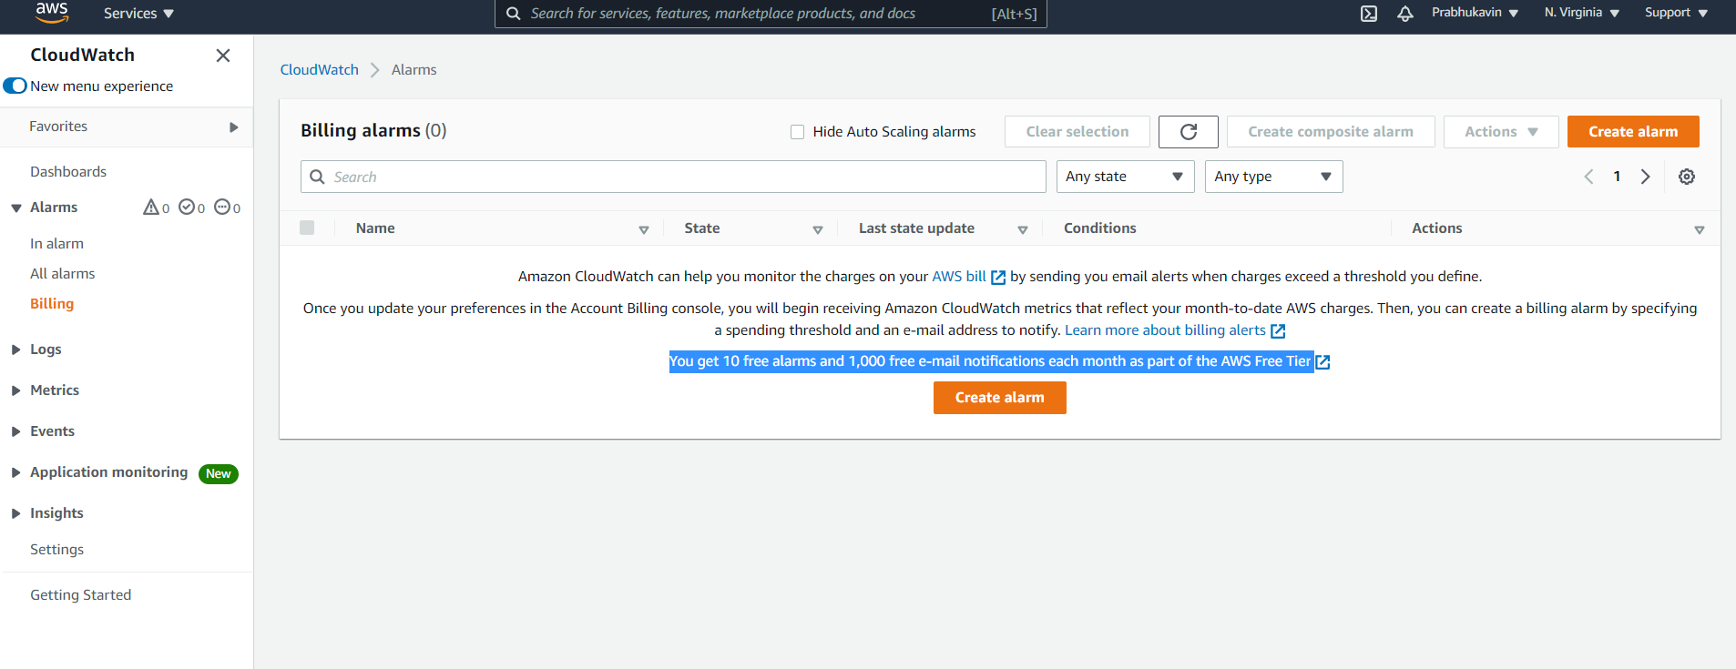

**Click on Create Alarm:**

**For company purpose they can give the limit to 500$ or 1000$ depending upon their requirements. Here for learning purpose, we are going to give the limit as 1$.**

**Let the threshold condition be static.**

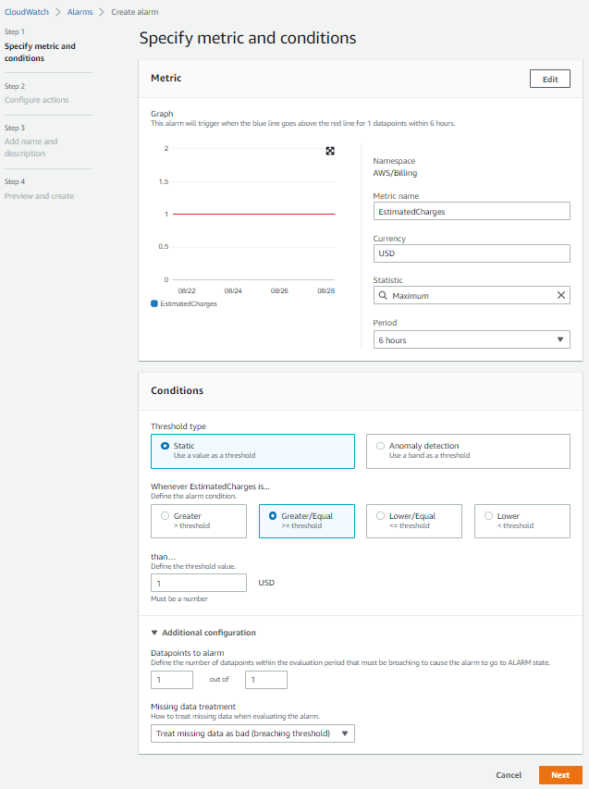

**As additional condition ”Treat missing data as bad(breaching threshold)”.**

**Click Next.**

1. **Configure Actions:**

**Create a new topic and give the email ID for receiving the notification.**

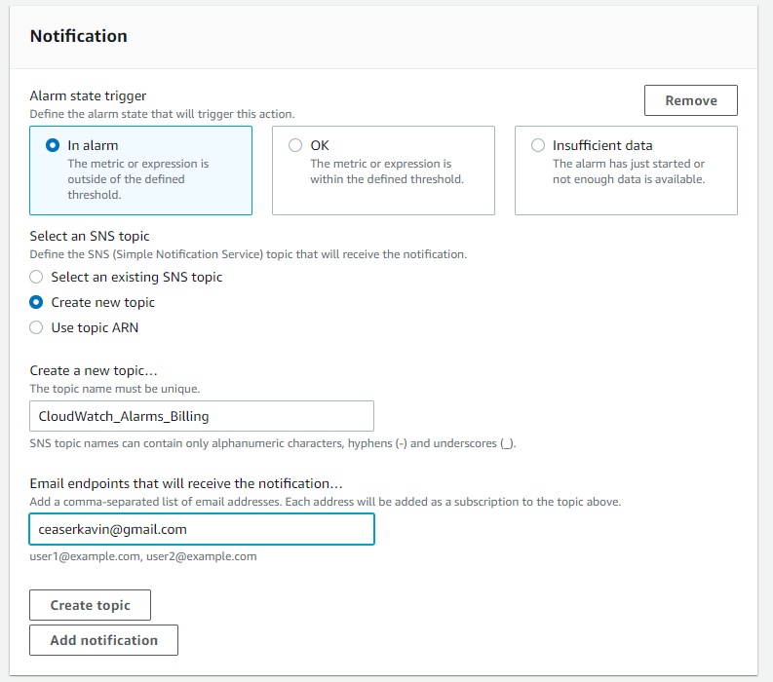

**Click on create topic.**

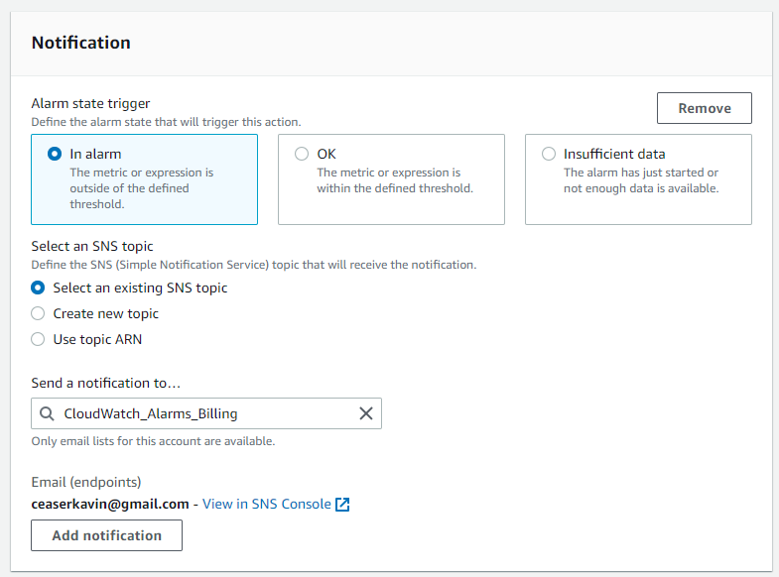

**You can also add the notification.**

**Accept the Email subscription mail sent by AWS SNS.**

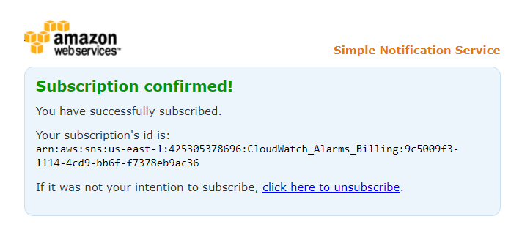

**Click Next:**

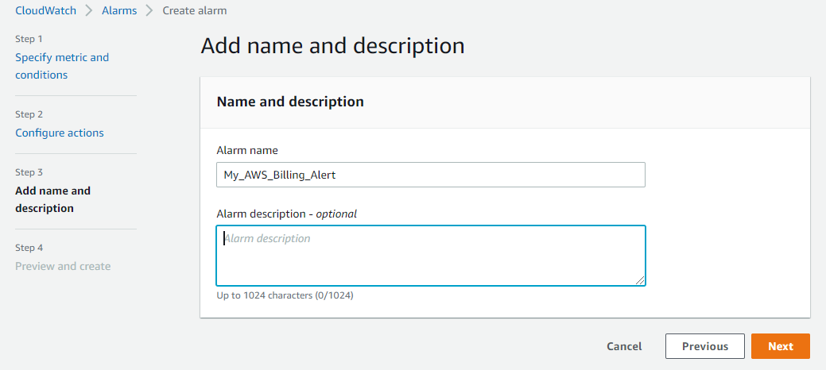

**Click Preview and create alarm:**

1. **Here the AWS Billing Alarm have been successfully created.**

